StationBase v 1.0

User Guide

2022-03-15

Demmery Software
#24 – 612 MacLaren Street
Ottawa ON K1R 5K9
CANADA
mizar64@gmail.com

TABLE OF CONTENTS

1. Introducing StationBase 3
2. Software Overview 4
3. Installation 5
Windows 5
Linux 5
4. Before You Begin... 6
5. The Main Screen 7
5.1 The Data Grid 8
5.1.1 Filtering Controls 9
6. Settings 10
6.1 Custom International Colours 12
6.1.1 Adding Countries 13
6.1.2 Editing Existing Colour Definitions 14
6.2 The Locations Manager 15
6.2.1 Location Details screen 16
6.3 The Equipment Sets Manager 18
6.3.1 Equipment Set Definitions 19
6.4 The Equipment Items Manager 21
6.4.1 The Equipment Item Details screen 21
6.5 The Frequency Bands Manager 22
6.5.1 Frequency Band Details 23
7. Working with Stations 24
8. Reception Reports 27
9. The Log 28
9.1 Log Entry Details 29
10. The Statistics Center 31
11. The Data Center 33
11.1 Maintain Subsets 35
12. Technical Specifications 37
13. Backup Instructions 38

1 Introducing StationBase

StationBase was programmed by a long-time DXer/programmer, in the Lazarus IDE, using Free Pascal. It is free for non-commercial use and distribution.

StationBase was designed with efficiency in mind. The interface was built to make most common operations (including entering data) a snap.

StationBase maintains several databases:
- Stations
- Reception Reports
- Locations (shared with Log)
- Equipment Sets (shared with Log)
- Equipment Items (shared with Log)
- Networks
- Log Entries
- Locations (shared with Stations)
- Equipment Sets (shared with Stations)
- Equipment Items (shared with Stations)
- Radio Bands

In addition to the above:
- Station records themselves can stand alone. Using Locations and Equipment Sets is entirely optional.
- Reception Reports are attached to stations, and can record the location from which the station was heard, and the equipment used to make the logging.
- Log entries also record location and equipment, but are not attached to station records.

Limits:
StationBase enforces the following limits:
- Stations: 10,000
- Reception Reports: 50,000
- Log Entries: 50,000
- Locations, Equipment Sets, Equipment Items, Networks, Radio Bands: 255

Some of these limits will be increased (pending demand) in a future version.

Note that StationBase is not designed to hold large, comprehensive databases of stations, such as national or international listings. It is designed purely to facilitate keeping DXing records organized.

2 SOFTWARE OVERVIEW

StationBase is built on a custom database-and-indexing framework.

Data relations are as follows:

Stations
-> Networks (optional)
-> Reception Reports
-> Locations (optional)
-> Equipment Sets (optional)

Log Entries
-> Locations (optional)
-> Equipment Sets (optional)

Frequency Bands (display only)

Custom Colours (display only)

All database files are maintained in the subfolder "Data", located directly below the stationbase program folder.

StationBase was developed with the Lazarus IDE and libraries, using the Free Pascal language. Free Pascal is available on many platforms and follows a "Write Once, Compile Anywhere" ethic. StationBase is aimed at the casual DXer, and for that reason imposes limits on stations and Reception Reports (approximately 30,000 records each).

About The Author
William C. Demmery has about 40 years' experience programming in his own time, and ten as a Professional Software Developer. A polymath, he has been a bookkeeper, an Administrative Assistant; an author; a Technical Writer; a software tester, computer servicing/installation technician, producer of a weekly community radio comedy show for many years, website designer. He is extremely knowledgable about astronomy, meteorology, radio, addictions, and the sciences in general. He began DXing on Christmas night, 1975, under the covers with a pocket radio.

3 INSTALLATION

In this section, it is presumed that you have downloaded the StationBase .ZIP file.

Basic Installation:
The following elements constitute a minimal StationBase installation:
\StationBase
StationBase.exe
StationBase.ico
\Data
ColourDefs.txt
systemproperties.ini

The basic installation will create the database and index files.

To Install in Windows:

- Create a StationBase folder on one of your drives.
- Extract the contents of StationBase....zip to \StationBase
  - Ensure that \StationBase\Exports exists
- Create a Desktop Shortcut:
  - Right-click on your menu bar, and select "Show Desktop"
  - Right-click on an empty spot on your Desktop, and select "New"
  - From the cascading menu, select "Shortcut"
  - In the box for the command, type C:\StationBase\StationBase.exe
(substitute the actual drive and path used)
  - Select [Next]
  - In the following screen, type in StationBase
  - Click [OK]
  - At this point, you may copy your shortcut to the menu bar.

Run StationBase by double-clicking on the Desktop shortcut.

To Install in Linux:

- Create a StationBase folder in your user folder /home/{user}/StationBase
- Extract the contents of StationBase....zip to /StationBase
- Create a Desktop Shortcut

Run StationBase by double-clicking on the Desktop shortcut.

4 BEFORE YOU BEGIN...

Before starting out, please note the following oddities:
- Stations are indexed by callsign, active status and frequency. This means that while two stations on the same frequency may have the same callsign, one of them must be inactive. Two station records may not share the same frequency, callsign and active status.
The best approach is simply to ensure that you have no station records which share the same frequency and callsign. What the author does, in those rare situations, is to assign the second station record a callsign like: WFME(2).
- Frequencies are indexed to the nearest Hertz. This means that stations with frequencies below 1 Hz will show up near the top of the list, but otherwise unsorted.
Demmery Software believes that this should not pose an issue at the present time.
- Please note that StationBase was designed around reasonable record-Count limits as to what a DXer might accomplish in his or her lifetime. It was not designed to serve as a reference database. If there is demand, a future version could be created to accommodate large record counts.

Please direct all bug reports, new feature requests, etc., to the author at mizar64@gmail.com.

5 THE MAIN SCREEN

On running StationBase, you will see the Main Screen.

This screen is designed to show you a list of the stations you've received. You can quickly filter the list by frequency range, location from which heard, equipment used for the logging, active vs. inactive stations, or by user-specified search criteria.
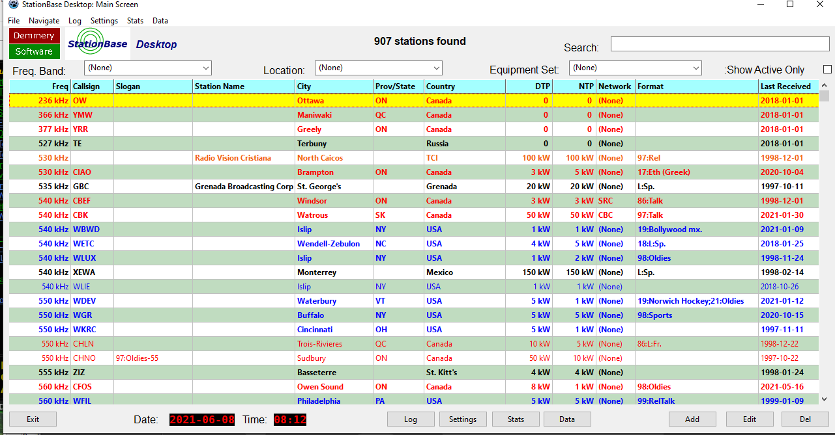
The StationBase Main Screen

In the example, I'm using my actual dataset. You will see that there are longwave and mediumwave stations listed. I've also got shortwave and FM loggings. You will also note that I am not keeping power information for longwave stations.

You will notice that stations are sorted per frequency first by active status (inactive stations at the bottom), and then by callsign. Active stations are displayed in bold.

StationBase is designed to accept loggings of frequencies from 1Hz to 9,999.999 THz. You can select the base unit, but the stations will always sort correctly.

* While it is possible to enter a frequency such was 0.001 Hz, the indexing routine rounds to the nearest hertz; therefore, stations with frequencies below 1 Hz will not sort correctly. That said, so far as the author knows, there is no station on earth that radiates on such a low frequency.

5.1 The Data Grid

The data grid shows the stations that you have logged to date. Some thought was put into the data displayed. At present, an alternating, ledger-like background is used; this may be changed, in future, to a colour-coding scheme by frequency.

The text colour of stations is based on their nationality and is user-defined.

Note that active stations show up as bold, and inactive as plain text.

Stations are sorted first by frequency, then by active status, then by callsign.

To select a station, click once. The [Edit] and [Delete] buttons affect the selected station.

5.1.1 Filtering Controls

A set of five filtering controls help you constrain what is displayed in the station grid.

Freq. Band (default: None)
Narrows your choices to a Frequency Band (see 6.5: The Frequency Band Manager, p. 23). Any stations in the range between the band's low and high frequencies, inclusive, are displayed.

If you know the name of the Frequency Band, you can type it into the box. When you exit the field, the system will attempt to find the entry. It will first look for exact matches, then the first partial match. If it cannot find the band indicated, it will clear the field.

If you open the dropdown, you will see a list of your Frequency Bands. To select a particular band, click on its entry. The station list will update, showing only stations within that band.

Location (default: None)
Narrows your choices to stations which have been received from a given Location (see 6.2: The Locations Manager, p. 15).

If you know the name of the Location, you can type it into the box. When you exit the field, the system will attempt to find the entry. It will first look for exact matches, then the first partial match. If it cannot find the Location indicated, it will clear the field.

If you open the dropdown, you will see a list of your Locations. To select a particular Location, click on its entry. The station list will update, showing only stations which have been received from that Location.

Equipment Set (default: None)
Narrows your choices to stations which have been received using a given Equipment Set (see 6.3: The Equipment Sets Manager, p. 18).

If you know the name of the Equipment Set, you can type it into the box. When you exit the field, the system will attempt to find the entry. It will first look for exact matches, then the first partial match. If it cannot find the Equipment Set indicated, it will clear the field.

If you open the dropdown, you will see a list of your Equipment Sets. To select a particular set, click on its entry. The station list will update, showing only stations which have been received using that Equipment Set.

Show Active Only (default: unchecked)
When checked, only stations which are marked 'active' (see 7: Working with Stations, p. 24) are displayed. You might mark a station as not active if, for example, it shut down, or changed its callsign or frequency.

Search
This is a very powerful tool. As you type, your station list is searched for any occurrence of your search string--including numeric values. The author uses this tool extensively to search, for example, for stations on a particular frequency ("1460", "101.3"), or from a particular city ("Ottawa", "Philadelphia"). The search updates as you type--note that if you have a large station list, performance will be slower. To clear the search, simply delete what you've typed.

5.1.2 MAIN SCREEN CONTROLS

Left-to-right, the buttons along the bottom of the screen have the following functions:

[Exit]: Exit the program.
[Log]: Access the Log feature. (See 9: The Log, p. 27)
[Settings]: Access the StationBase Settings page. (See 6: Settings, p. 10)
[Data]: Access the Data Center. (See 11: The Data Center, p. 32)
[Stats]: Access the Stats Center. (See 10: The Statistics Center, p. 30)
[Add]: Adds a new station to the database. (See 7: Working with Stations, p. 24)
[Edit]: Edit an existing station. (See 7: Working with Stations, p. 24)
[Del]: Delete an existing station. (See 5: The Main Screen, p. 7)

6 SETTINGS
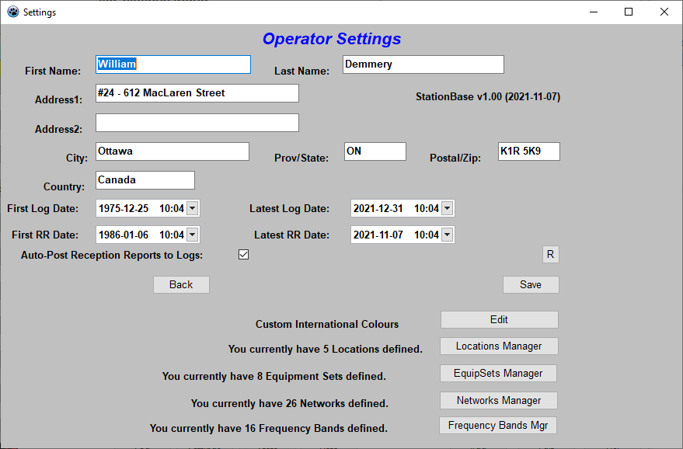
The Settings screen

The Settings screen is where you control how StationBase works, and where you maintain your background data.

First off: a word about privacy.

With StationBase, your data are yours, period. Nothing is transmitted anywhere; StationBase doesn't even use the Internet. How much or how little data you enter is entirely up to you; but it is stored only in the StationBase working files, and in any output files you may have generated.

The first fields are just for you to keep your own information straight.

The four date fields are imputed from the information you enter into StationBase, but can be changed.

There is one control of which you should be aware:

Auto-Post Reception Reports to Log
If checked, then all Reception Reports you enter are also made into Log entries. The Log is a convenience tool only.

The other buttons on the Settings screen are for editing background information:

Custom International Colours - [Edit]
Allows you to edit the foreground colours in which stations from various countries are displayed. (See 6.1: Custom International Colours, p. 12s)

[Locations Manager]
This button allows you to access the Locations Manager, from which you manage the various locations from which you DX. (See 6.2: The Locations Manager, p. 15)

[EquipSets Manager]
Allows you to access the Equipment Sets Manager, from which you can manage your equipment sets and individual equipment items. (See 6.3: The Equipment Sets Manager, p. 18)

[Frequency Bands Mgr]
Allows you to manage Frequency Bands (Radio Bands). These are purely for you to group and filter your stations. (See 6.5: The Frequency Band Manager, p. 22)

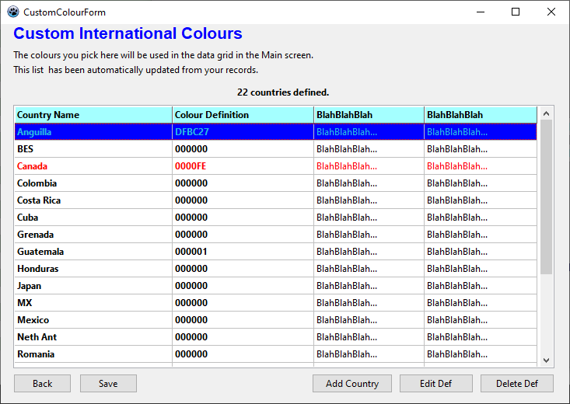
6.1 Custom International Colours
The Custom International Colours list

The International Colours List is a list of colours assigned to various countries around the world. It is not a complete list; you can add to it yourself. The colour that you choose for a country will be used to display stations in the Station Grid.

Here are the controls on the screen:

[Back]: Go to the previous screen. If you have pending changes, you will be prompted to save them.
[Save]: Save any changes that you have made, and return to the previous screen.
[Add Country]: Allows you to add a country definition to the list.
[Edit Def]: Allows you to edit an existing colour definition
[Delete Def]: Deletes the currently highlighted definition, after first prompting you for confirmation.

6.1.2 Adding Countries

When you click on [Add Country], The Country Colour Definition Box dialog will open:
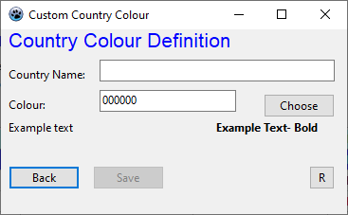

The Country Colour Definition dialog (Add Country)

The fields are quite straightforward:

Country Name: Enter the name of the country as it appears in the database
Colour: The foreground colour definition.
Example text below shows what text would look like in the currently selected colour.

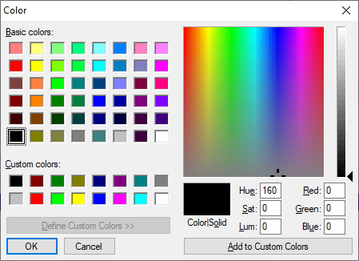
[Choose]: Opens the colour picker to choose the colour directly.

The Colour Picker

Here, you select either a pre-set colour, or choose from the palettte. Click [OK] or [Cancel] when done.

The [R] button resets the fields on the form.

6.1.3 Editng Existing Colour Definitions

When you click on the [Edit Def] button, the Colour Definition dialog will open as before. This time, you will not be able to edit the country name; but you can select a new colour.
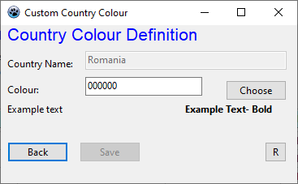

Colour Definition (Existing Country)

As before, you can click on [Choose] to select from the colour picker.

[Back] or [Save] to exit the form.

6.2 The Locations Manager

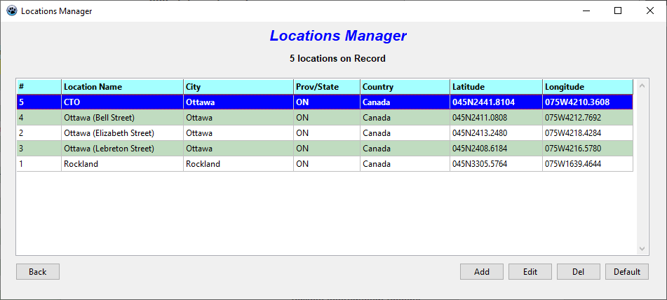
The Locations Manager

If you have Locations entered, they will appear here. Note that the default Location is higlighted.

From here, you can manage the locations from which you DX or have DXed.

The five buttons along the bottom of the window are as follows:

[Back]: Return to the previous screen.
[Add]: Add a new Location to the database. You will be presented with the Location Details screen (see next page).
[Edit]: Edit the currently highlighted Location. You will be presented with the Location Details screen (see next page).
[Del]: Delete the currently highlighted Location. You will be asked for confirmation before deleting.
[Default]: Allows you to designate the currently highlighted Location as the default Location, in which case it will be offered as the default Location for new Reception Reports and Log Entries.

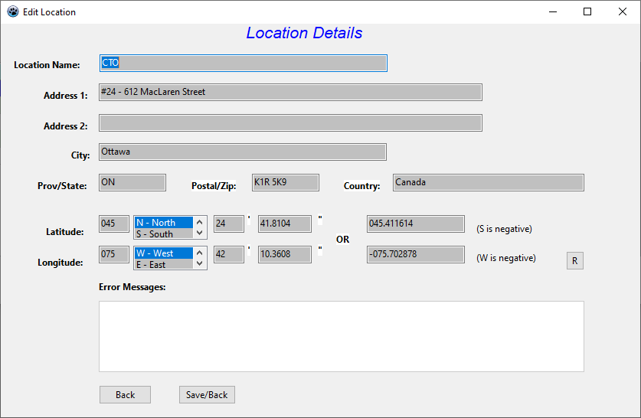
6.2.1 The Location Details Screen

The Location Details screen

The Location Details screen records the essential details of a DXing Location.

The fields are as follows:

Location Name: A name for your location.
Address 1, An address for your location (if applicable)
Address 2:
City: The city of municipality of your DXing Location
Prov/State: The province, state or other political subdivision of your DXing Location.
Postal/Zip: The postal, ZIP or other postal-routing code for your DXing Location.
Country: The country of your DXing Location.
Latitude, The latitude and longitude of your DXing Location. Each allows you to enter a latitude or longitude value either as degrees (E/W/N/S), seconds and decimal minutes, or as a GPS-style, signed decimal coordinate.
Longitude: Latitude and Longitude are used in conjunction with station coordinates to calculate distances to stations.

*Note: If the Latitude or Longitude is changed, all distances will be recalculated in applicable Reception Reports.

There are three buttons onscreen:

[R]: Reset the fields on the screen
[Back]: Return to the Locations Manager screen, without saving any changes you have made
[Save/Back]: Save the changes you have made, and return to the Locations Manager screen.

6.3 The Equipment Sets Manager
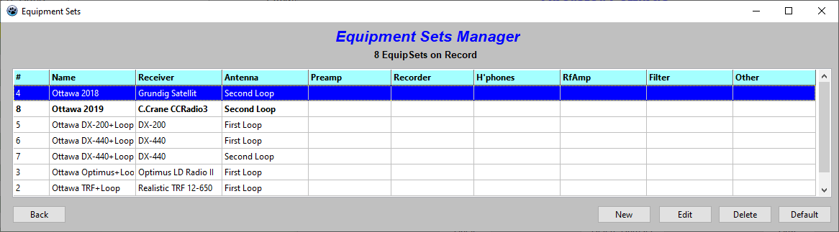
The Equipment Sets Manager

The Equipment Sets Manager lets you manage the pieces of equipment you use in your DXing. Again, Equipment Sets are entirely optional.

The grid displays the various sets of equipment with which you work. Each equipment set has provision for one receiver, one antenna, etc. They are assigned from your list of equipment items (see below).

The controls on this screen are:

[Back]: Return to the previous screen.
[New]: Add an Equipment Set definition to the collection (See Equipment Set Definitions, below).
[Edit]: Edit an existing definition.
[Delete]: Delete an existing definition, after first propmting you for confirmation.
[Default]: Make the currently highlighted entry the Default Equipment Set; it is the one initially offered when entering new Reception Reports and Log Entries.

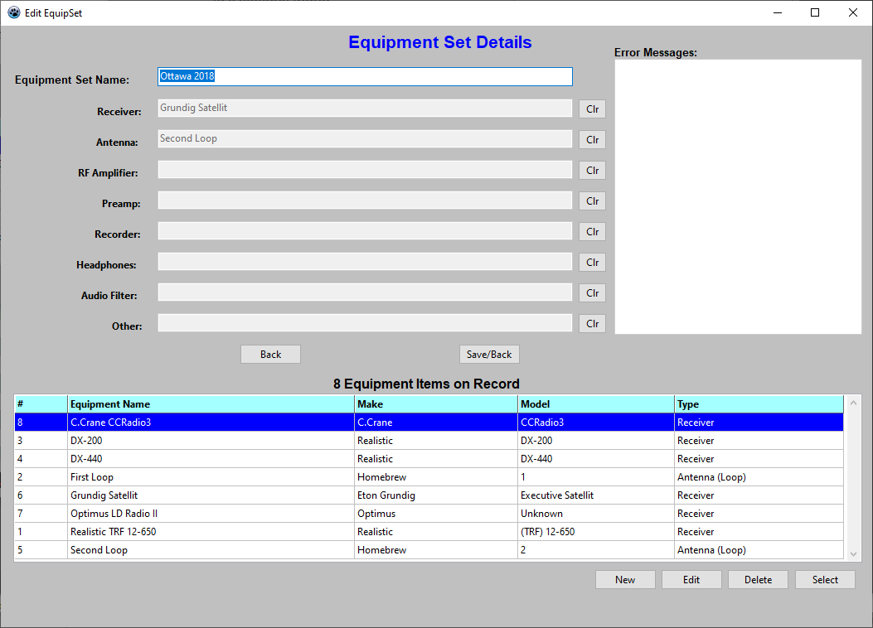
6.3.1 Equipment Set Definitions

When you click on [Add] or [New] in the Equipment Manager (EM) screen, you will be presented with the Equipment Set Details screen.
The Equipment Set Details / Equipment Item Manager screen

As you can see, this is a combination screen, displaying the data from this Equipment Set (ES); but it also provides a list of individual equipment items.

The fields for the ES are quite simple:

Equipment Set Name: The name of this ES.
Receiver: The receiver used in this ES.
Antenna: The antenna used in this ES.
RF Amplifier: Any RF amplifier used in this ES.
Preamp: Any audio preamplifier used in this ES.
Recorder: Any recording device used in this ES.
Headphones: Any headphones used in this ES.
Audio Filter: Any audio filter used in this ES.
Other: Any other equipment used in this ES.

The two buttons on the page are as follows:

[Back]: Exit back to the previous page, without saving.
[Save/Back]: Save your changes and exit the page.

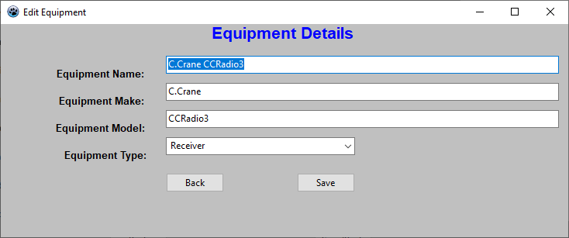
6.4 The Equipment Items Manager

The Equipment Items Manager (see previous page) allows you to manage the individual items of equipment that you use in your DXing.

There are four buttons below the EI grid.

[New]: Add a new item of equipment to the pool. (See Below)
[Edit]: Edit an existing item of equipment. (See Below)
[Del]: Delete the currently highlighted piece of equipment, after first propting you for confirmation.
[Select]: Add the piece of equipment to the currently displayed ES. It will take over the slot designated for its equipment category.

6.4.1 The Equipment Items Details Screen
The Equipment Details screen

There are four fields, here. They are fairly self-explanatory.

Equipment Name: Name for this piece of equipment
Equipment Make: The make, or brand name
Equipment Model: The model number or name
Equipment Type: This accesses a list of equipment types, as outlined above.

[Save] Save the changes you have made.
[Back] Exit to the previous screen, discarding your changes.

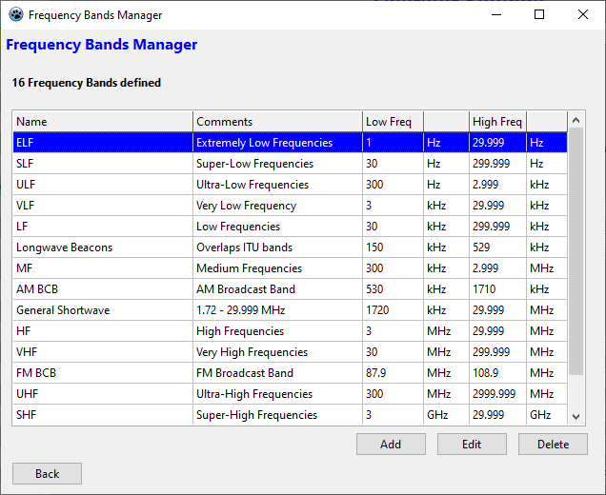
6.5 The Frequency Bands Manager
The Frequency Bands Manager

As explained previously, frequency bands are just to help you keep your stations sorted.

You can have up to 255 band definitions. Overlapping frequencies ranges are fine.

There are four controls on this page:

[Back]: Exit to the previous page.
[Add]: Add a new Frequency Band to the list (See Below).
[Edit]: Edit the currently highlighted definition (See Below).
[Delete]: Delete the currently highlighted definition, after being prompted for confirmation.

6.5.1 Frequency Band Details
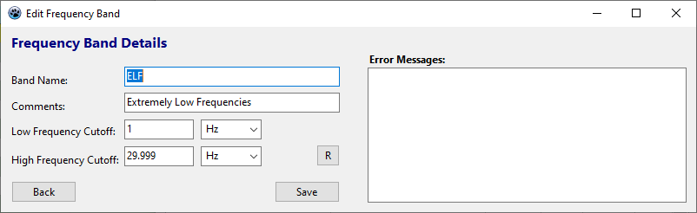
Frequency Band Details

The fields on this screen are as follows:

Band Name: The name for this frequency band.
Comments: Additional comments about this frequency band.
Low Frequency Cutoff: The frequency where the band begins. Remember that up to three decimal numerals can be entered; but also that frequencies below 1 Hz don't have much meaning to StationBase.

The second part of this field is the Multiplier selector. It allows the following magnitudes to be selected:
Hz
KHz
MHz
GHz
THz
High Frequency Cutoff: The frequency where the band ends.
The second part of this field is the Multiplier selector. It allows selection of the same range of magnitudes as for the Low Frequency Cutoff.

7 Working With Stations

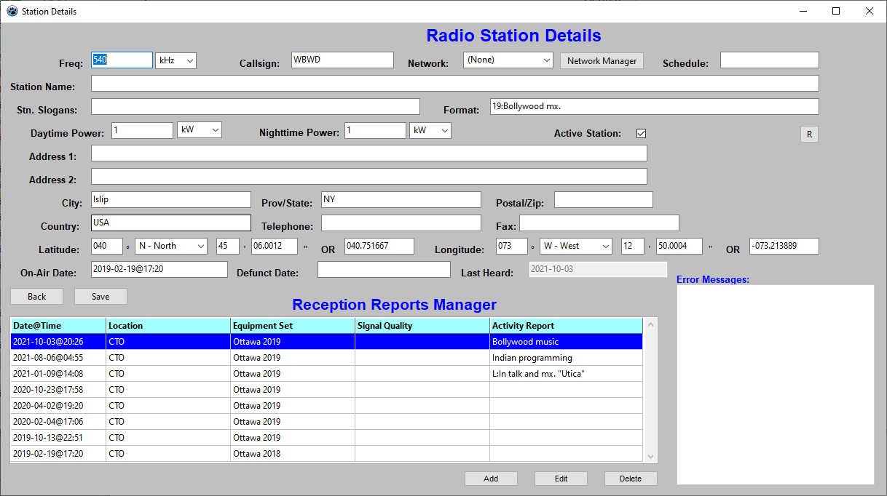
When you click on [Add] or [Edit] in the main screen, you will be presented with the Station Details screen.
The Station Details screen

Here, you enter as much or as little information as you please.

You do have to enter a frequency and callsign or station name.

Here is an explanation of each field:

Freq: The station's frequency. The acceptable range is 0.001 to 999.999
The second part of this field is the Multiplier selector. It defaults to 'kHz'. Your choices are:
Hz
kHz
MHz
GHz
THz
Callsign: The station's callsign. Either this field, or Station Name, must be populated.
Network: If you choose to use it, you can select the station's network. If the network is not in the list, then you can access the [Network Manager] and add it.
Schedule: This is just a text field to enter schedule information. I usually use it to indicate daytime-only stations.
Station Name: If the station has an official name, you should enter it here. Either this field, or Calisign, must be populated.
Station Slogans: Any slogans used by the station.
Format: Format info (station programming type)
Daytime Power: The daytime power used by the station. This can be from 0.001 to 999.999.
The second part of this field is the Multiplier selector. It defaults to 'kW'.
Your choices are:
mW
W
kW
MW
GW
Nighttime Power: The nighttime power used by the station. This works the same as the Daytime Power field.
Active Station: When this box is checked (default), the station is considered active (on-the-air according to its schedule). When the boxis unchecked, the station is considered defunct.
Address1, Address2: Two lines for the station's postal address.
City: The name of the city to which the station is registered.
Prov/State: The province, state, or other political subdivision in which is located the city of registration.
Postal/Zip: The Postal Code, ZIP code, or other postal routing code for the station.
Country: The country from which the station broadcasts.
Telephone: The station's telephone number.
Fax: The station's FAX number.
Latitude: This is a multi-part field. You can enter the latitude of the station, either as degrees(N/S)-minutes-decimal-seconds, or as a single, signed GPS-style coordinate.
Latitude and longitude values are used in conjunction with Location coordinates to calculate distance values for Reception Reports.
Longitude: This is a multi-part field that works exactly the same as the Latitude field.
On-Air Date: The date the station first appeared on the air. If no date is entered here, it will be imputed from Reception Reports.
Defunct Date: The date the station went off-the-air.
Last Heard: The date a Reception Report was last filed for the station.

*Note: If either Latitude or Longitude is changed, all distances in Reception Reports for that station will be recalculated!

Onscreen also there are three buttons:

[Save]: Save the station entry, and exit the page.
[Back]: Exit the page without saving changes.
[R]: Reset the fields on the page.

NOTES:

- When entering a new station, the [Save] button is initially disabled.
- Three fields are checked each time there is an update: Frequency (must be populated), Callsign and Station Name (one of the two must be populated), and Active status (for each callsign/frequency combination. Duplicates (matched on Frequency, Callsign/Station Name, and Active status) are not permitted.

To be clear: you can enter two stations with a particular frequency and callsign; one has to be Active, the other not. You will be warned if you a duplicate entry is detected.

One all of the conditions are met, the [Save] button will be enabled.

Once a station record is saved, the Reception Reports area becomes available.

8 Reception Reports

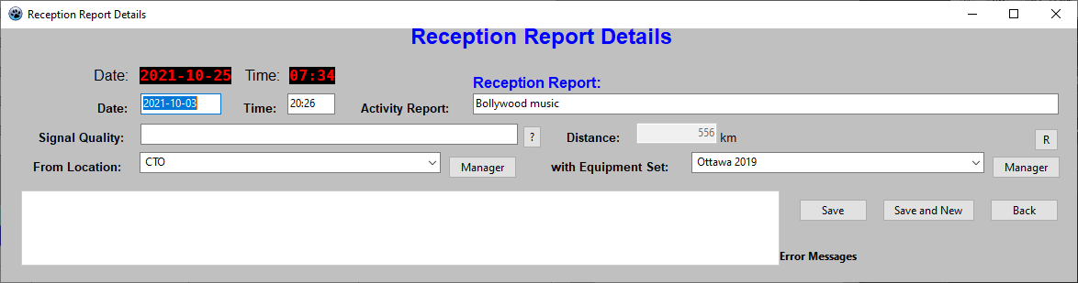
In the Station Details screen, on clicking the [Add] or [Edit] button, you will be presented with the Reception Report Details screen.
Reception Report Details

Each Reception Report is a logging of a station.

The fields on this screen are as follows:

Date: The date of the logging. Dates can be entered in multiple ways:
YYYY-MM-DD
YY-MM-DD (if YY > 50, it will be interpreted as a 20xx year; otherwise 19xx)
YYYYMMDD
YYMMDD (if YY > 50, it will be interpreted as a 20xx year; otherwise 19xx)
Time: The time of the logging. 24-hour time is expected, and can be entered in multiple ways:
HH:MM
HHMM
Activity Report: A description of what was heard.
Signal Quality: A description of the signal quality.
Distance: The calculated distance to the station, in kilometres.
From Location: Here you can select the Location from which you heard the station. You may also access the Locations Manager.
Equipment Set: Here you can select the set of equipment that was used to hear the station. You may also access the Equipment Sets Manager.

The four controls on this page are:

[Save]: Save the Reception Report details and exit the page.
[Save and New]: Save the Reception Report and begin another. This is particularly useful when entering historical loggings.
[Back]: Exit the page without saving.
[R]: Reset the fields on the page.

9 The Log

The log is a convenience tool; it allows logging of information that is not automatically incorporated in the station database.

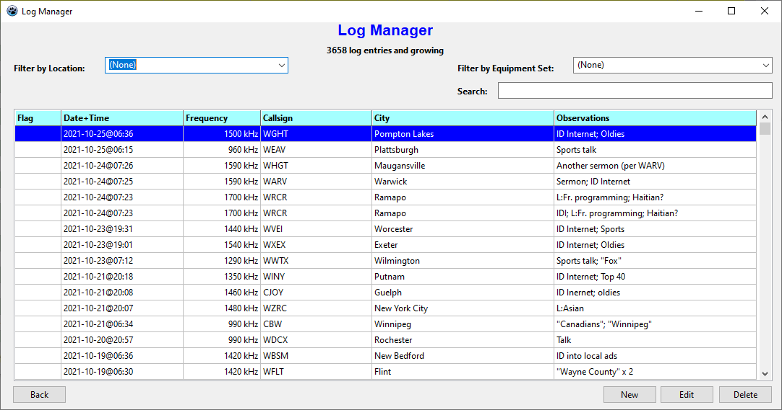
Clicking on the [Log] button from the Main Screen will present you with the Log Manager screen:
The Log Manager screen

Here, your log listings are displayed. If you have Stations with Reception Reports, and the system is set to cross-post automatically, then you will have Log entries. Otherwise,unless you use your log, you will not.

The filtering controls are similar to those of the Main Screen, though not as extensive.

Filter by Location: Filters the entries only to show those which were made at the given Location.
Filter by Equipment Set: Filters the entries only to show those which were made using the given Equipment Set.
Search: An interactive search function that updates results as you type.

The controls at the bottom of the window are as follows:
[Back]: Go back to the Main Screen.
[New]: Create a new Log entry.
[Edit]: Edit the currently highlighted Log entry.
[Delete]: Delete the currently highlighted Log entry.
9.1 Log Entry Details

Upon clicking [New] or [Edit] on the Log Manager screen, you will be presented with the Log Entry Details screen.
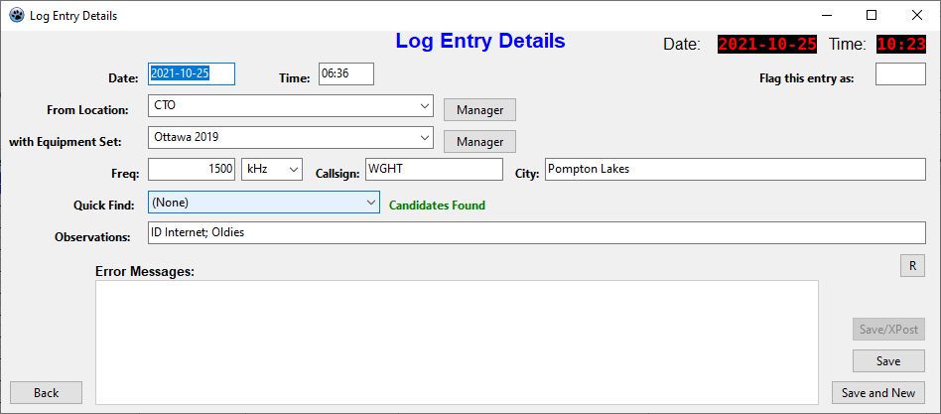
Log Entry Details

The fields on this screen are as follows:

Date: The date of the logging. Dates may be entered in multiple formats:
YYYY-MM-DD
YY-MM-DD (if Y>50, it will be interpreted as 19xx, else 20xx)
YYYYMMDD
YYMMDD (if Y>50, it will be interpreted as 19xx, else 20xx)
This is a required field.
Time: The time of the logging. Times may be entered in multiple formats:
HH:MM
HHMM
This is a required field.
Flag this entry as: Allows you to set a 'flag' for the entry, so that it will catch your attention in the listing.
from Location: Allows you to select the Location from which you made the Log entry.
with Equipment Set: Allows you to select the Equipment Set with which you made the logging.
Freq: The frequency. This is a required field.
Callsign: The callsign (if known)
City: The city from which the station was broadcasting (if known)
Quick Find: If stations in the database match the frequency and callsign, the list will be populated with choices.
Observations: What you were hearing; signal quality; etc.

The five controls along the bottom of the window are as follows:

[Back]: Exits the screen without saving your changes.
[Save/XPost]: If your log entry has not already been cross-posted to the Reception Reports database, then you can do so now.
[Save]: Save your changes, and exit the screen.
[Save/New]: Save your changes, and begin a new Log entry.
[R]: Reset the fields onscreen.

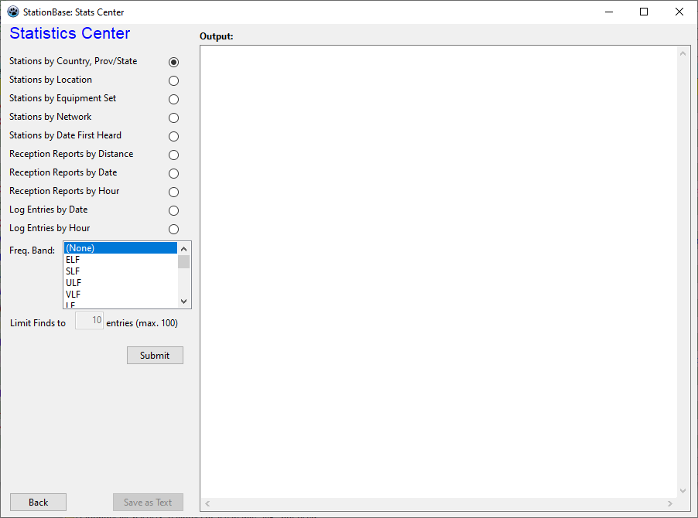
10 The Statistics Center

The Stats Center allows you to extract some basic statistics from your dataset.
The Stats Center

The controls are:
{Type of listing} - Checkboxes. Select the type of listing desired.
Freq. Band: Limit the results to entries within a given frequency band.
Limit Finds to xx entries: Where multiple entries may occur (dates, frequencies, etc.), only show the first xx entries for each set.
[Submit]: Request your stats. They will appear in the window, and can optionally be saved in text format.
[Back]: Exit the screen.
[Save as Text]: Save your results as a text file.

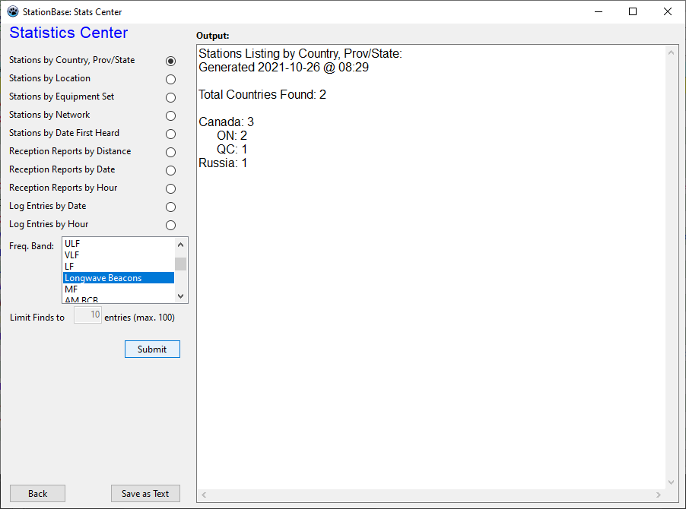
Here is an example: we have just run station stats, by country and province/state, for Longwave Beacons.

Stats Center with Stats Showing
11 The Data Center

The Data Center allows you to extract lists of all your database entries, with filtering. In this way, it is possible to 'package up' your entries for import into another system.
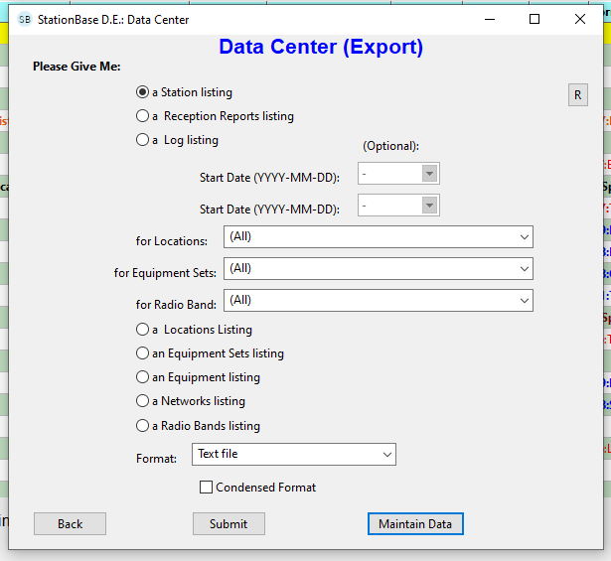
Data Center

This page is more complicated, and detailed descriptions follow for each of the onscreen controls.

Station Listing Generate a listing of Station records
Reception Reports Listing Generate a listing of Reception Report records.
Log Listing Generate a listing of Log records.

The following five controls only apply to the above three:

Start Date When Start Date or End Date is defined, only records from after the Start Date (inclusive) and/or before the End Date (inclusive) are included in the listing.
End Date When Start Date or End Date is defined, only records from after the Start Date (inclusive) and/or before the End Date (inclusive) are included in the listing.
for Locations: When a Location is set, only records using the Location are included.
for Equipment Sets: When an Equipment Set is set, only records using that Equipment Set are included.
for Radio Band: When a Radio Band is set, only records within that Radio Band are included.
Locations Listing: Request a list of Location records.
Equipment Sets Listing: Request a list of Equipment Set records.
Equipment Listing: Request a list of Equipment Item records.
Networks Listing: Request a listing of Networks.
Radio Bands Listing: Request a listing of Radio Bands.
Format: The output format of the listing. Currently three formats are supported:
- Text file (Records separated by a space; fieldnames = values
- CSV file (Records occupy single lines, comma-delimited)
- XML file (Records defined in XML format)
Condensed Format: When a text file or XML output is desired, checking this box ensures that all empty fields are omitted from the listing.
[Back]: Exit the screen.
[Submit]: Submit your request. The listing will be generated, and you will be prompted for a place to save it.
[Maintain Subsets]: Enters the Maintain Subsets screen, from which you can delete different categories of data, or reindex them.

11.1 Maintain Subsets

Warning: before visiting this page, be sure to have backed up your StationBase Data folder! The operations described below can cause permanent destruction of parts or all of your dataset.
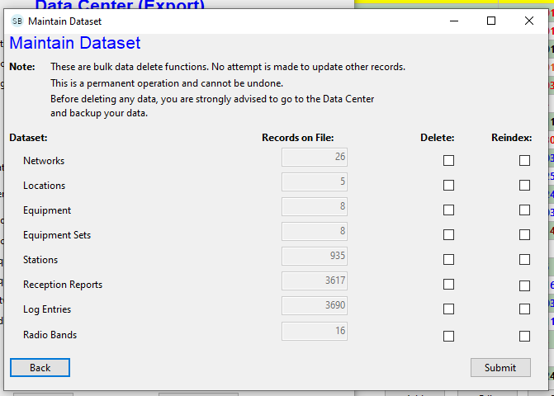
Maintain Dataset screen

Note that there are two columns of checkboxes. If you place a checkmark in the Delete column, then the corresponding dataset will be deleted. If you place a checkmark in the Reindex column, then the corresponding dataset will be reindexed.

(Re-indexing is not normally needed. It is there just in case your dataset starts to behave unpredictably.)

Two controls on this page:

[Submit]: Go ahead and delete or reindex the subset(s) selected. You will first be prompted. When the delete operation is done, the record count will be updated.
[Back]: Return to the Data Center page.

12 Technical Specifications

Record Limits:
Stations: 10,000
Reception Reports: 50,000
Log Entries: 50,000
Locations: 255
Equipment Sets: 255
Equipment Items: 255
Networks: 255
Radio Bands: 255

Record Storage Format:
Table file: *.db

Index file: *.idx

13 Backup Instructions

You will want periodically to backup your StationBase data.

The simplest way is to create a copy of the StationBase Data folder.
The author has created a folder on his drive, called "StationBaseBackups".
Into this folder he pastes the Data folder, then renames it to include the date.

You can also backup your data by creating export files. (see 11: The Data Center, p. 32).

